Pleasant Point Park History
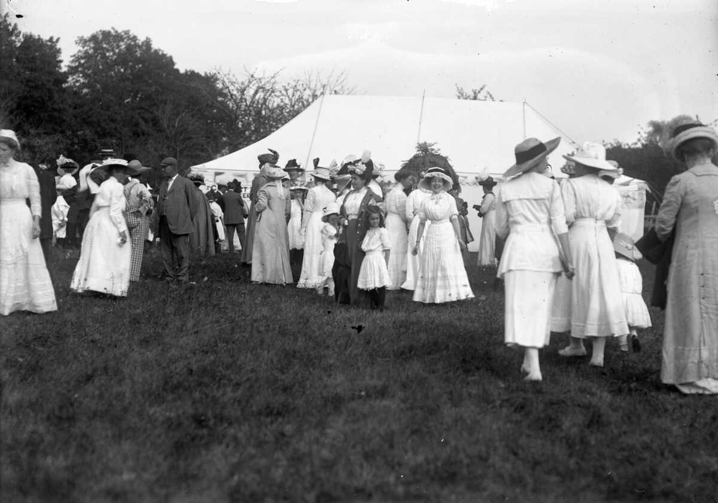

1741 – First colonial settlement of the farm by the Joseph Woodman family. Abandoned soon after due to the French and Indian War.
1750 – Joseph Woodman and wife Mary return permanently.
1754 – Second Buxton side fort built on the Woodman farm near Simpson Road. The first fort was on Joy Valley Road. The fall of Quebec in 1759 leads to peace and settlement in the area.
1774 – Burial Ground established using only unmarked fieldstones. Last burial in 1817.
1906 – Mary Woodman donates the Woodman farm to the Appalachian Mountain Club in memory of her father Clarence Woodman. It is later donated by the club to the State of Maine and then to Buxton in 1971.
1912 – Dorcas Fair held in the field of the Woodman Reservation farm on July 30. See the photo above.
1922 – 150th Buxton Anniversary Tribute Program to the Early Settlers held at the Pleasant Point Woodman farm
1948 – Skelton Dam completed. Water level raised to the Bar Mills dam.
1972 – At Buxton’s 200th Anniversary, the Buxton-Hollis Historical Society erects a plaque for 42 people known to be buried at the cemetery including Joseph Woodman and his wives, Mary Tarbox Cole and Reliance Thompson Edgecomb.
2009 – Excavation of the 1754 fort which was built by William Hancock.

The first colonial settlement on the site was by the Joseph Woodman family of Newbury, Mass. about 1741. They had to retreat to Biddeford for many frontier war years, but came back to their farm by 1750. Joseph (1715-1796) died at his daughter’s farm in Hollis, but was buried at the Pleasant Point burial ground with his wives, other family and neighbors.

The 2009 archaeological survey noted many historic items of interest in the park, including; The Hon. John Woodman house and barn foundations at Simpson Road, the other John Woodman house foundation at the Point, the Captain Joseph Woodman house foundation, the 1754 fort remains, the Nathaniel Woodman house foundation, a brick manufactory from as early as 1750, and a small granite quarry which made house foundations. The archaeological dig artifacts include pottery and household items. They will be on display at the Buxton-Hollis Historical Society at 100 Main Street, Bar Mills.

On this, the 250th Anniversary of Buxton’s incorporation, we are grateful for the Woodman family who have shared this wonderful site with us and have done so much for Buxton.

